***Project Report***

***On­­­***

**Web development(Study group)**

**Submitted for the requirement of**

**Project course**

BACHELOR OF ENGINEERING

**COMPUTER SCIENCE & ENGINEERING**



**Submitted by**

**SHUBHAM**

**18BCS1059**

**Submitted to:-**

**Ms. Arshleen**

**DEPARTMENT OF COMPUTER SCIENCE & ENGINEERING**

**CHANDIGARH UNIVERSITY, GHARUAN**

**September 2020**

### CERTIFICATE

This is to certify that the work embodied in this Project Report entitled **“Web development(Study group)”** being submitted by **“ SHUBHAM ”** UID **“18BCS1059 ” ,** 5th Semester for partial fulfillment of the requirement for the degree of **“ Bachelor of Engineering in Computer Science & Engineering ”** discipline in “ **Chandigarh University** ” during the academic session JULY-DEC 2020 is a record of bonafide piece of work, carried out by student under my supervision and guidance in the **“ Department of Computer Science & Engineering ”, Chandigarh University.**

**APPROVED & GUIDED BY:**

**Ms. Arshleen**

### DECLARATION

I, student of Bachelor of Engineering in Computer Science & Engineering, 5th Semester , session: Jul – Dec 2020, Chandigarh University, hereby declare that the work presented in this Project Report entitled “**Web development(Study group)** ” is the outcome of my own work, is bona fide and correct to the best of my knowledge and this work has been carried out taking care of Engineering Ethics. The work presented does not infringe any patented work and has not been submitted to any other university or anywhere else for the award of any degree or any professional diploma.

**Student details**

**SHUBHAM(18BCS1059)**

**K2-G1**

**APPROVED & GUIDED BY:**

**Ms. Arshleen**

To our parents, teachers and all the well wishers out there . . .

### 

**ABSTRACT**

Web development is the process of creating a computer program or a set of programs to perform the different tasks that a business requires.

Web development(Study group )in this project I am going to make a workable website which will contain information about different types of exams in India.

The main field of study for this project is web Development i.e a workable website or software project which can be used in various smartphones.

Right now there are various systems which can help in making a website and I am going to use one of the i.e notepad in order to make this website.

I am going to use JAVA,HTML programming language to make this website

These are the steps followed in the project:-

1. Firstly ,I am building an website which will provide a buying and selling platform for different types of exam materials all around india.

2. This website name is Study group and it will also provide information about those antiques products which will be added by sellers.

3. More improvements can be done in this website by providing a bargain or negotiation platform.

**TABLE OF CONTENT**

|  |  |  |  |  |
| --- | --- | --- | --- | --- |
| Contributions | | |  | I |
| Acknowledgements | | | | Ii |
| Project Description | | | |  |
| 1 | Introduction | | | 1 |
| 2 | Background | | | 2 |
|  | 2.1 | Website Development . . . . . . . . . . . . . . . . . . . . . . . . . . . . . . . . . . . . . . | | 3 |
|  |  | 2.1.1 | Types of Websites Software . . . . . . . . . . . . . . . . . . . . . . . . . . . . . . . . . . . | 4 |
|  |  | 2.1.2 | Advantages of my Website . . . . . . . . . . . . . . . . . . . . . . . . . . . | 5 |
|  | 2.2 | Motivation . . . . . . . . . . . . . . . . . . . . . . . . . . . . . . . . . . . . . . . . . | | 6 |
|  | 2.3 | Specifications and Goals . . . . . . . . . . . . . . . . . . . . . . . . . . . . . . . . . . | | 7 |
|  | 2.4 | Design overview | |  |
|  |  |  | |  |
|  | 2.5 | Summary . . . . . . . . . . . . . . . . . . . . . . . . . . . . . . . . . . . . . . . . . . | | 8 |
| 3 | System Design | | | 9 |
|  | 3.1 | Project Overview . . . . . . . . . . . . . . . . . . . . . . . . . . . . . . . . . . . . . . | | 10 |
|  |  | 3.1.1 | The Research Stage . . . . . . . . . . . . . . . . . . . . . . . . . . . . . . . . | 11 |
|  |  | 3.1.2 | Building & Interfacing Stage . . . . . . . . . . . . . . . . . . . . . . . . . . . | 12 |
|  |  | 3.1.3 | The Programming Stage . . . . . . . . . . . . . . . . . . . . . . . . . . . . . . | 13 |
|  | 3.2 | Physical Components . . . . . . . . . . . . . . . . . . . . . . . . . . . . . . . . . . . . | | 14 |
|  | 3.3 | Software . . . . . . . . . . . . . . . . . . . . . . . . . . . . . . . . | | 16 |
|  |  | 3.3.1 | Android Studio . . . . . . . . . . . . . . . . . . . . . . . . . . . | 17 |

|  |  |  |  |
| --- | --- | --- | --- |
| 3.4 | Summary . . . . . . . . . . . . . . . . . . . . . . . . . . . . . . . . . . . . . . . . . . | | 18 |
| 4 Experimental Results | | | 19 |
| 4.1 | Implementation . . . . . . . . . . . . . . . . . . . . . . . . . . . . . . | | 20 |
| 4.2 | Diagrams and achievements . . . . . . . . . . . . . . . . . . . . . . . | | 26 |
| 4.3 | Outcome . . . . . . . . . . . . . . . . . . . . . . . . . . . . . . . . . . . . . . . . . . | | 28 |
|  |  |  |  |
|  |  |  |  |
|  |  | |  |
| 5 Difficulties  6.Conclusions | | | 29 |
| 7.References/Bibliography | |  | 30 |

**CONTRIBUTIONS**

I want to contribute the success of this project to my project mentor and to all my teachers who helped me out and finally to myself.

I also want to thank the university for providing the resources for the completion of the projects.

**Acknowledgement**

I would like to express my thanks to my teachers and mentors who helped me to complete this project entitled “**Website Development(Study group)**” on time and guided me every time I was facing any kind of problem.

## Project Description

**1. Introduction**

Website Development (Study group) in this project I am going to make a workable website which will contain information about different types of antique items in India.

The main field of study for this project is Website Development i.e a workable website or software project which can be used in various smartphones.

Right now there are various systems which can help in making a website and I am going to use one of them i.e Android studio in order to make this website.

I am going to use JAVA programming language to make this website.

**2. Background**

This section includes the general background information on the Website Development(Study group). This section also covers our goals and specifications for the project undertaken.

**2.1 Website Development**

Website development is the process of creating a computer program or a set of programs to perform the different tasks that a business requires.

There are various types of websites which can be developed like :-

Websites related to healthcare, business, education, food industry etc.

**2.1.1 Types of Website Software**

Website development is the name of the profession that employs people who design, develop and deploy these computer websites.

Website developers have a computer programming background. As you might imagine, the reason it's called website development instead of just computer programming is because there are many more steps involved before and after the actual writing of the computer program. All of those steps are very typical and are collectively called a systems development lifecycle.

| **Website Software Type** | **Examples** |
| --- | --- |
| Word processing software | MS Word, WordPad and Notepad |
| Database software | Oracle, MS Access etc |
| Spreadsheet software | Apple Numbers, Microsoft Excel |
| Multimedia software | Real Player, Media Player |
| Presentation Software | Microsoft Power Point, Keynotes |
| Enterprise Software | Customer relationship management system |
| Information Worker Software | Documentation tools, resource management tools |
| Educational Software | Dictionaries: Encarta, BritannicaMathematical: MATLABOthers: Google Earth, NASA World Wind |
| Simulation Software | Flight and scientific simulators |
| Content Access Software | Accessing content through media players, web browsers |
| Website Suites | OpenOffice, Microsoft Office |
| Software for Engineering and Product Development | **IDE** or Integrated Development Environments |

**2.1.2 Advantages of website Development(study group)**

There are various advantages like:-

a) It helps the customers so that they can sell or get information about any antique product they have.

b) It is highly cost effective.

c) It helps in Providing a single platform for negotiation and product information.

d) It do real time analysis which helps in getting information about recent products which are posted.

e) It provide search option with search tags for more efficient use.

**2.2 Motivation**

When I registered for this course I was not sure what I was going to do and I was just thinking about how I can make a app which not only work like a normal website but better than the present websites.

I was thinking about how to extract data and how I am suppose to code it.

Then I asked my mentors and they told me to read review papers and then I studied on my own and finally I was able to make this project and it really was a fun journey.

**2.3 Specifications and Goals**

The goal of my project is to design, implement, and create an website named as Study group which will It help the customers so that they can sell or get information about any antique product they have and helps in Providing a single platform for negotiation and product information.

**2.4 Design Overview**

Well I am going to create an website named as Study group in which I am going to provide a buy-sell platform for different type of antique’s all around india and provide information about them as well.

Also, you can schedule your shipping details. You have to provide the proper shipping details.

In order to make this website I am going to use Android Studio.

**So, Firstly I have to install the Android Studio and to do so I have to follow the following steps:-**

1. Before installing the Android SDK, you need to install the Java Development Kit (JDK).

2. Then “Install Android Studio" @ <https://developer.android.com/studio/install>.

3. Remember to install Android Studio according to your Operating System i.e. Windows and Mac.

4. After the installation is complete start creating your app.

Now, there are a few things we need to keep in mind in this project i.e.

This whole project was developed in the Android studio. Here the Java programming language is used for field verification and XML language for data transfer. This project continues to ask you about updating plugins to keep your internet alive. And in addition, you will need to update your SDK version and you should also update your quick start plugins.

Now, comparing this project with an existing one: -

1. Currently all existing projects that offer buy and sell platform do not provide antique details.

2. Secondly, I am trying to make the program in which it will perform following features:-

* Buy & Sell Antique
* Add antique to cart
* Search for antique information
* Provide a payment option
* Ship to the provided address

**2.5 Summary**

The aim of this project is to develop an website named as Study group which will It help the customers so that they can sell or get information about any antique product they have and helps in Providing a single platform for negotiation and product information.

This project was a great learning opportunity for me to apply my engineering knowledge. The thesis addresses the difficulties I faced throughout the project. It also open up the possibilities to broaden the understanding and websites of JAVA programing language.

**3. System Design**

This section explains in details how the project was approached. All hardware and software components that will be used will be explained in this section of the report. Problems encountered and solutions to these problems will not be mentioned in this section of the report.

**3.1 Project Overview**

The ultimate goal of this project is to design an an website named as Study group which will It help the customers so that they can sell or get information about any antique product they have and helps in Providing a single platform for negotiation and product information.

. The end result of this project could be used for these websites in future developments in this field.

. This project was split into four main stages; the research stage, the building and interfacing stage, and the programming stage. Each stage will be explained more thoroughly in the following sections of this document.

**3.1.1 The Research Stage**

The research stage was a critical stage that provided me with the knowledge necessary to complete the other stages of my project. This stage was an ongoing process that I had to return to many times during the development process to gain the knowledge needed to continue on with the project.

My research encompassed a wide range of sources, which included studies done at different universities and hobby enthusiast sources. My research included the previous development in the field of Website Development, choosing correct programming language which is fast and easy to use, Search for a software which can help in doing sentimental analysis.

Also I have to research about various types of Websites and the types of Website Software in order to make an ideal project.

**3.1.2 Building & Interfacing Stage**

This stage started when I decided the type of Website I wanted to build and various functions it should perform. During this stage I focused on verifying and testing each component thoroughly. The testing process will be explained in greater detail in a later section in this document.

In building part I have to decide the programming language which I choose to be JAVA then I decided the software and finally come to a conclusion that I should go with Android Studio.

**3.1.3 The Programming Stage**

In this stage of I have to design the code by synchronizing it with the software I am using i.e Android Studio.

Here is the design of the programming stage:-

Then comes the procedure for installation:-

**So, Firstly I have to install the Android Studio and to do so I have to follow the following steps:-**

1. Before installing the Android SDK, you need to install the Java Development Kit (JDK).

2. Then “Install Android Studio" @ <https://developer.android.com/studio/install>.

3. Remember to install Android Studio according to your Operating System i.e. Windows and Mac.

4. After the installation is complete start creating your app.

Here are the snapshot of demo code on Android Studio:-

**In the above code I have written the basic syntax of the program.**

**Here “maven.google.com” is a repository which contain various artifacts for different projects.**

**3.2 Physical Components**

Now, let’s talk about the physical components of this project,In this project there aren’t many physical components cause it basically a software based project not mechanical based.

But here are the few components which are necessary:-

a) Hardware requirement:-Microsoft windows, at least 3 GB RAM, Latest processor but beginner should be Pentium not less than that.

b) Internet connection is required so you need either a LAN wire or Wi-Fi connection. That’s all in physical components requirement.

**3.3 Software**

This section include all the information required about different types of software’s used in my project and how to install them (which I have also discussed in above phases)

The subsections describes all the software components of my project and how they work.

**3.3.1**  **Notepad**

**So, Firstly I have to install the Android Studio and to do so I have to follow the following steps:-**

1. Before installing the Android SDK, you need to install the Java Development Kit (JDK).

2. Then “Install Android Studio" @ <https://developer.android.com/studio/install>.

3. Remember to install Android Studio according to your Operating System i.e. Windows and Mac.

4. After the installation is complete start creating your app.

**3.4 Summary**

In this section the hardware and software components were explained in detail. The reasons for choosing each component was made clear.

**4. Experimental Results**

In this section of the document we will be discussing the verification and testing of each hard-ware and software component. All problems will be described in detail and the solutions we made to solve these problems. In this section we will also discuss our overall results of the project and what we could have done to improve upon our project. Future work for this project will also be mentioned in this section of the document.

**4.1 Implementation**

I have completed the project and here the screenshots of the website:-

The above snapshot represent the main/starting page.

It will be displayed when the website will start.

Then there is a option of category-wise search.

It help the user to search the product he is looking for easily.

In this website we can login or create new account using our facebook credentials for the time being.

We can create a new account using our mobile number as well.

Then there is a option of recent items in which newly added antique’s are displayed.

If we click on a item then it will provide the information added by the seller like product details, price, contact details etc.

**“The above pic is just for reference because there are no sellers registered on the app right now.”**

**4.2 Diagram and Achievements**



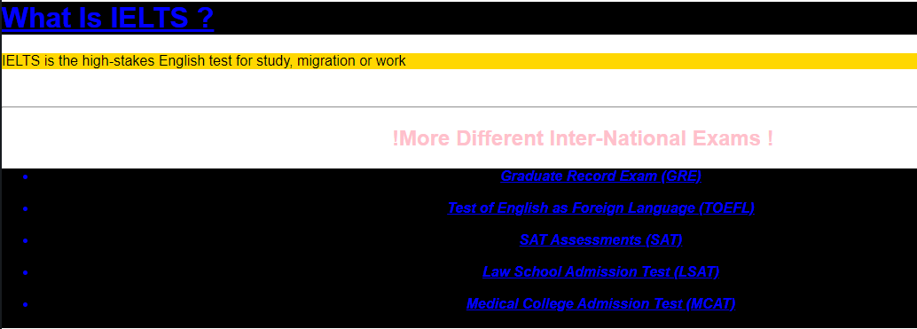

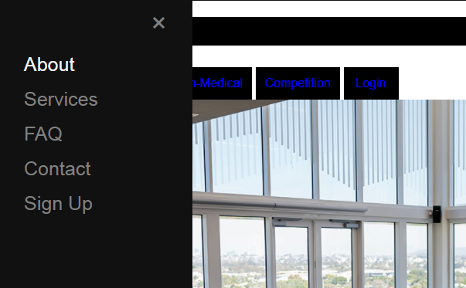

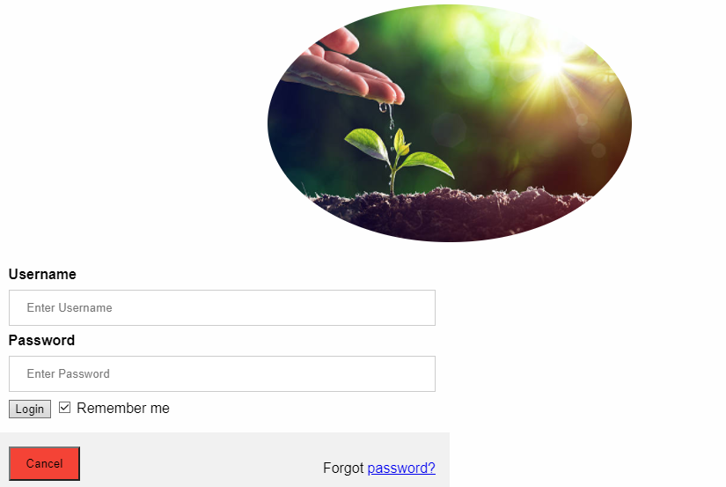

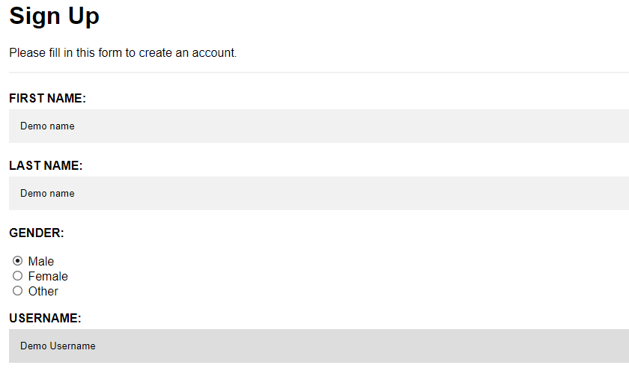

**Achievements:-**

a) First, I successfully created this website and it works better than I thought.

b) Secondly, it is highly efficient and provide good amount of information about the product.

c) Third, it can perform well even if a lot of people are using it together but it can be improved more.

**4.3 outcome**

The output can be calculated according to the code syntax which I have shared in the First progress report.

After completing the code on Android Studio and Running it we came to a conclusion that the website works perfectly fine.

Although there are some improvements which can be performed like providing sign up facility using google account and a chat feature between seller and buyer etc.

Advantages or websites of this app are:-

1. Fast sign up facility.

2. Information about the antique from various websites and by the seller.

3. Price can be fixed by seller but a bargain platform can also be provided.

4. With further improvements this can perform even in a more better way.

Comparison with other websites:-

1. This app provide hassle free sign up facility.

2. Can be improved by providing a bargain platform for buyer and sellers

3. Other apps doesn’t provide that much information regarding Antique’s.

**5. Difficulties**

1. I encountered difficulty in finding mentor cause it happened so fast that most of the mentors were already booked, but finally when I found one then she really helped me out in this project.

2. There are still some improvements which are needed in this website so it’s still not ready to launch

3. The last problem I faced was the lack of knowledge of software’s and the understanding of topic.

**6. Conclusions**

This section discusses the results of the project. All information here is repeated from earlier sections of this report. In the end the project was successfully implemented even after facing some serious problems. My project is all about designing an website named as Study group which will It help the customers so that they can sell or get information about any antique product they have

It also helps in Providing a single platform for negotiation and product information.

It is highly cost effective and helps in processing data at a large scale which reduce the work load.

It follows a consistent criteria which helps in providing results without an major problems. Therefore I will say that this website is really good and efficient but with some more improvements it can become the best.

**Bibliography**

1.“Android development report,” February 2013. [Online]. Available: https://prog.google.ca/



2. Tweepy software. Accessed: September 2012. [Online]. Available: [https://code.google.com/Android studio/](https://code.google.com/Android%20studio/)

3. https//geekeforgeeks/website development.

4. www.towarddatascience.com

5. www.textblob.readthedocs.io

6. www.github.com

7. [www.vendropslink.in](http://www.vendropslink.in)

8. . <https://samy.pl/skyjack/>

9. By [Acosta](http://edition.cnn.com/profiles/jim-acosta-profile) Jim, CNN Senior White House Correspondent, Updated 1818 GMT (0118 HKT) April 27, 2015